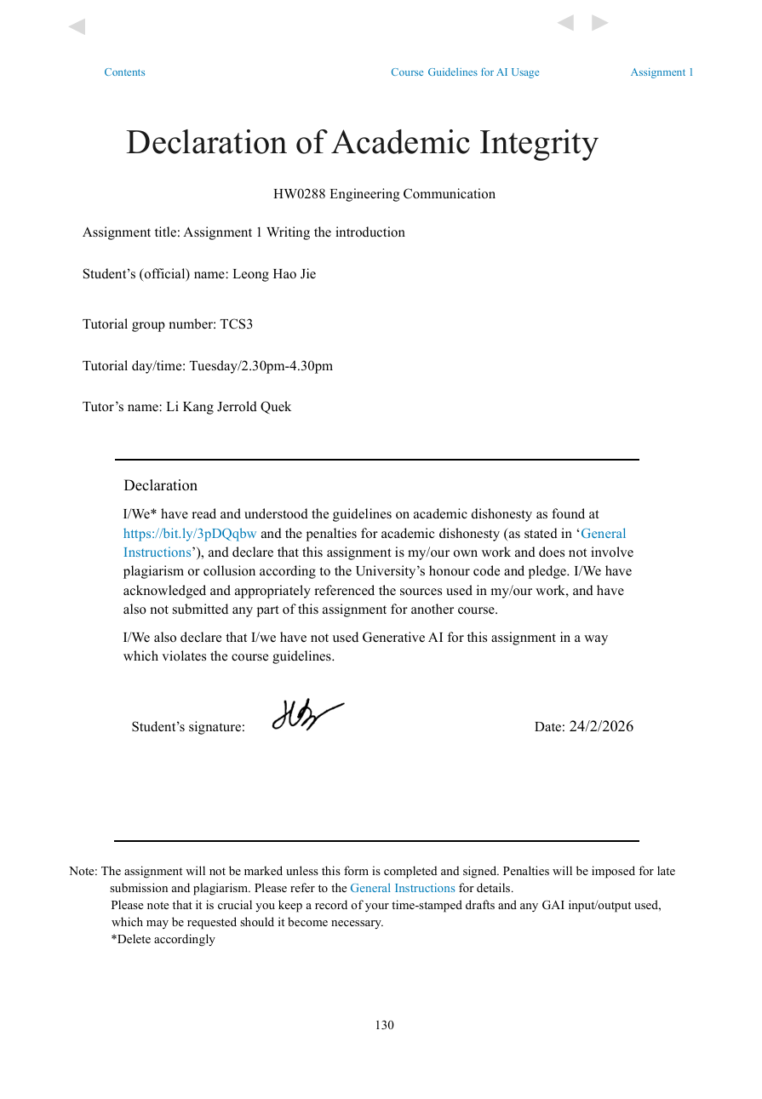

Micro-Investment App with Peer Comparison Dashboard

Digital financial technologies have changed the way people invest. Micro-investment platforms let users invest small amounts by buying fractional shares or setting up automatic contributions. This approach lowers the amount of money needed to get started and makes investing more accessible for young people [1]. New features like round-up deposits and scheduled investments make it easier to invest regularly without much effort. Because of these benefits, more students and young adults are using micro-investment apps.
Even though more people are using micro-investment platforms, most of them focus on tracking individual portfolios. Apps like Acorns [2] and Stash [3] offer simple interfaces and automatic investment options, but only provide users with basic feedback, such as portfolio balance, returns, and contribution history. These features make investing easier, but they do not help users compare their behaviour with others.
Research shows that comparing ourselves to others can affect how we make financial decisions. People are more likely to change their investment choices when they know about the financial behaviour of those around them [4]. Social interaction and the way information spreads also play a role in whether someone decides to participate [4]. This suggests that adding peer information could influence how people use financial systems. However, most micro-investment platforms do not include benchmarking dashboards as a main feature.
There is a gap between what behavioural finance research says about peer information and how it is used in micro-investment systems. Building peer-comparison features poses technical challenges, including user grouping, calculating summary statistics, building a scalable backend, and ensuring data privacy.
This project aims to design and build a mobile app that simulates micro-investments and includes a peer-comparison dashboard. The system architecture follows a “separation of concerns” approach [5], this allows users to set their own contribution rules, group users into anonymous peer groups based on specific profile traits, calculate group benchmarks such as medians and percentiles, and display these results clearly on a mobile dashboard.
To make peer comparisons useful, users are grouped by things they have in common, like how much they contribute or their risk preferences. Rather than showing individual portfolios, the system calculates group statistics, such as the median portfolio value or percentile rankings. This helps users see how they compare to similar people without revealing anyone’s personal financial information.
The app has a mobile interface that connects to a server for calculations and data storage. The server handles user inputs, updates simulated portfolio values, groups users, and calculates comparison metrics. All data is stored in a structured database that separates user profiles, contributions, and simulation results, ensuring accuracy and easy access.
This report will focus on the designing and building of the frontend interface, backend API services, database structure, and benchmarking calculations. The system will only simulate investments and will not handle real financial transactions. Using software architecture, data modelling, and analytics, the project will demonstrate how to build a scalable, privacy-focused micro-investment app with a peer-comparison dashboard for mobile use.

References
[1] U.S. Securities and Exchange Commission, “Investor Bulletin: Fractional Share Investing,” SEC.gov, 2020. [Online]. Available: https://www.investor.gov/introduction-investing/general-resources/news-alerts/alerts-bulletins/investor-bulletins/fractional-share-investing-buying-slice-instead-whole-share [Accessed: Feb. 21, 2026].
[2] Acorns, “Round-Ups,” Acorns Official Website, 2026. [Online]. Available: https://www.acorns.com/round-ups/ [Accessed: Feb. 22, 2026].
[3] Stash, “Fractional Shares Investing,” Stash Official Website, 2026. [Online]. Available: https://www.stash.com/invest/fractional-shares [Accessed: Feb. 22, 2026].
[4] Z. Lin, M. Kong, G. Li, and X. Wang, “The peer effects of resident stock market participation: Evidence from 2019 CHFS,” PloS one, vol. 19, no. 4, Art. no. e0298894, 2024, doi: 10.1371/journal.pone.0298894.
[5] N. Dragoni et al., “Microservices: Yesterday, Today, and Tomorrow,” in Present and Ulterior Software Engineering, B. Meyer and M. Mazzara, Eds., Switzerland: Springer International Publishing AG, 2017, pp. 195–216. doi: 10.1007/978-3-319-67425-4_12.

